**NAME**: PUDI PAVANI

**ROLL.NO**.: 2023BCSE07AED340

1. Imagine you are tasked with designing a humanoid robot to assist in a home or office environment.

The robot must be capable of interacting with people by **talking** and **listening**, **walking** to different

locations, **seeing** and recognizing objects, and **learning** from its surroundings to adapt its behavior.

What technologies, tools, and frameworks would you need to build such a robot? Give as flow chart

ANS:

1. User Interaction

Speech Recognition: Google Speech API, Whisper

Text-to-Speech (TTS): Google TTS, Amazon Polly

Chatbot AI: OpenAI GPT, Rasa

2. Movement Control

Motor Control: Arduino, Raspberry Pi, ROS

Navigation Sensors: LiDAR, Ultrasonic, Cameras

Path Planning: SLAM, A*, Dijkstra

3. Object Recognition & Vision

Camera Input: RGB, Depth Sensors

Object Detection: OpenCV, YOLO

Face Recognition: FaceNet, Dlib

4. Learning & Adaptation

AI Models: TensorFlow, PyTorch

Reinforcement Learning: OpenAI Gym

Data Storage: Cloud (AWS, GCP), Local (SQL, NoSQL)

5. Energy Management

Battery Monitoring & Optimization

2. Calculate and interpret mean, median, mode, variance and standard deviation for a given dataset.

Data =[ 15,21,29,21,15,24,32,21,15,30]

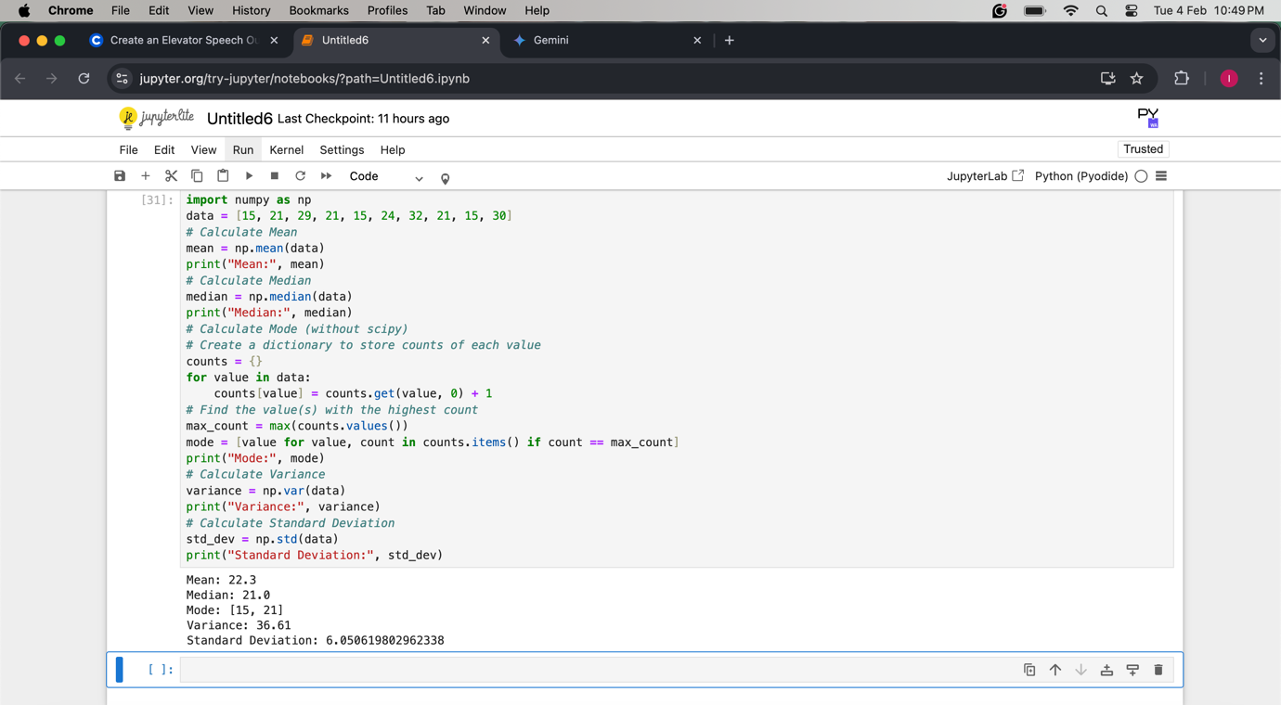

3. You are analysing a dataset that captures the daily performance and activity of a humanoid robot

in a simulated environment. The dataset link robot_dataset(robot_dataset)_1.csv includes the

following attributes

**Interaction Count**: Number of conversations the robot had daily.

**Steps Walked**: Total steps taken each day.

**Objects Recognized**: Number of objects successfully identified by the robot.

**Learning Sessions**: Number of learning tasks completed.

**Energy Consumption (kWh)**: Daily energy usage of robots.

**Perform Basic Statistical Operations:**

1) What is the **average (mean)** number of conversations the robot has daily?

2) Find the **total steps walked** by the robot over a given period.

3) Determine the **maximum and minimum energy consumption** in the dataset.

4) Calculate the **correlation** between the number of steps walked and energy consumption.

5) Analyse the **distribution** of objects recognized daily (e.g., histogram or box plot).

6) What is the **variance** in the number of

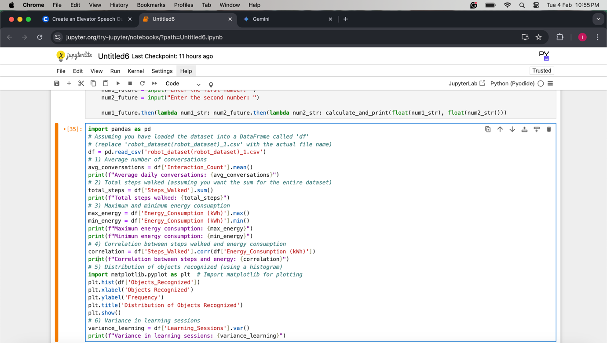

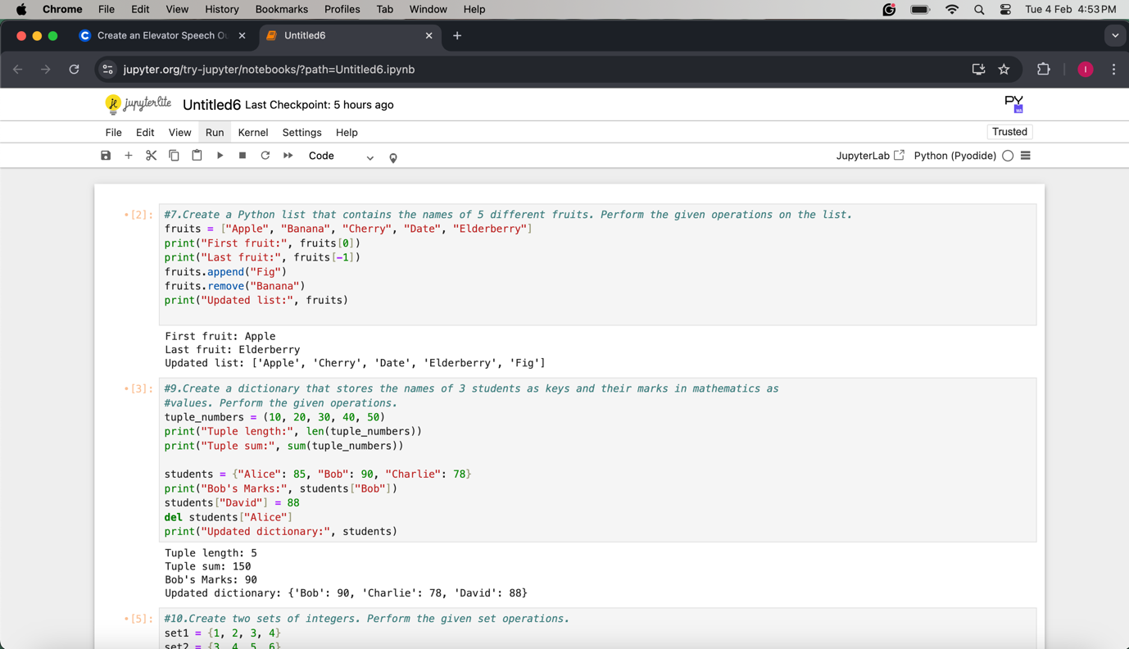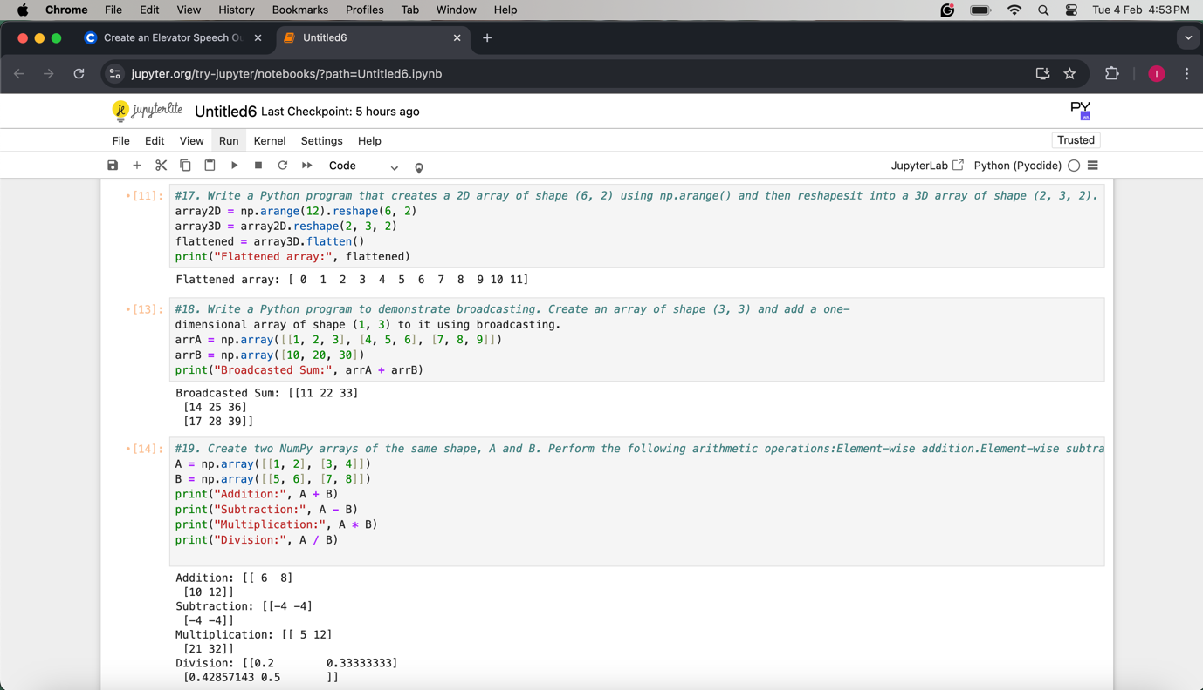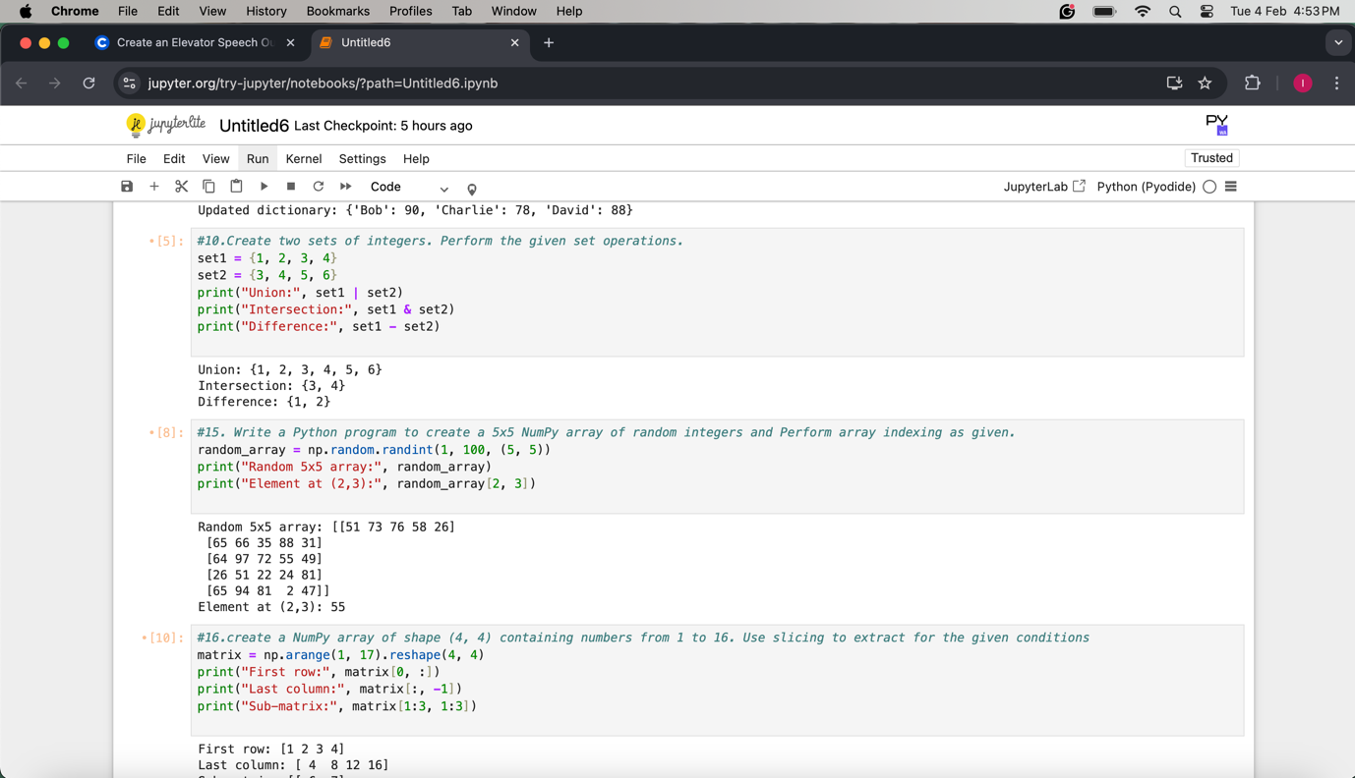

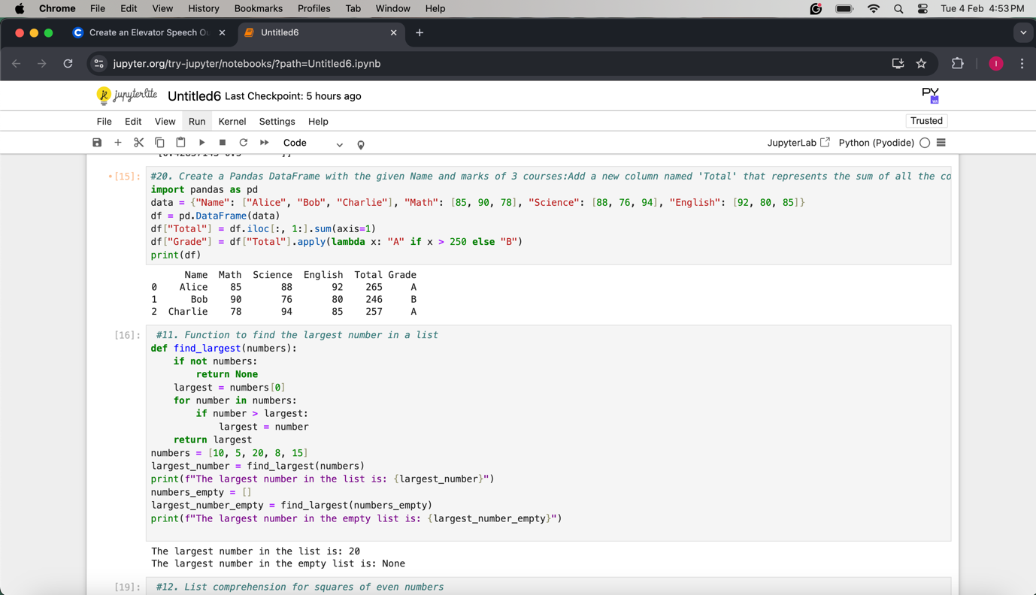

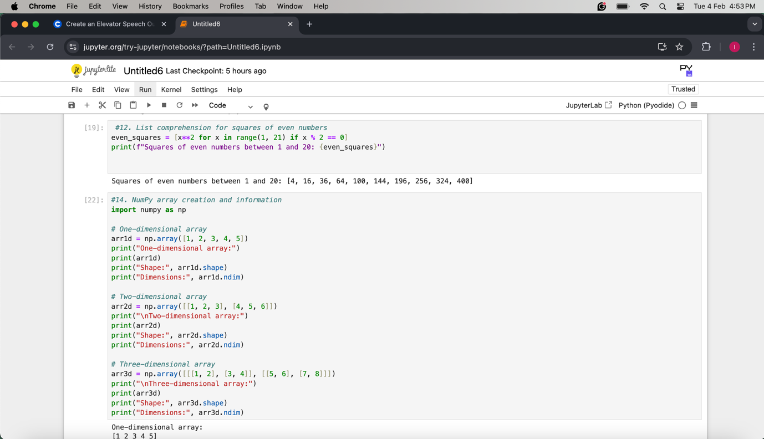

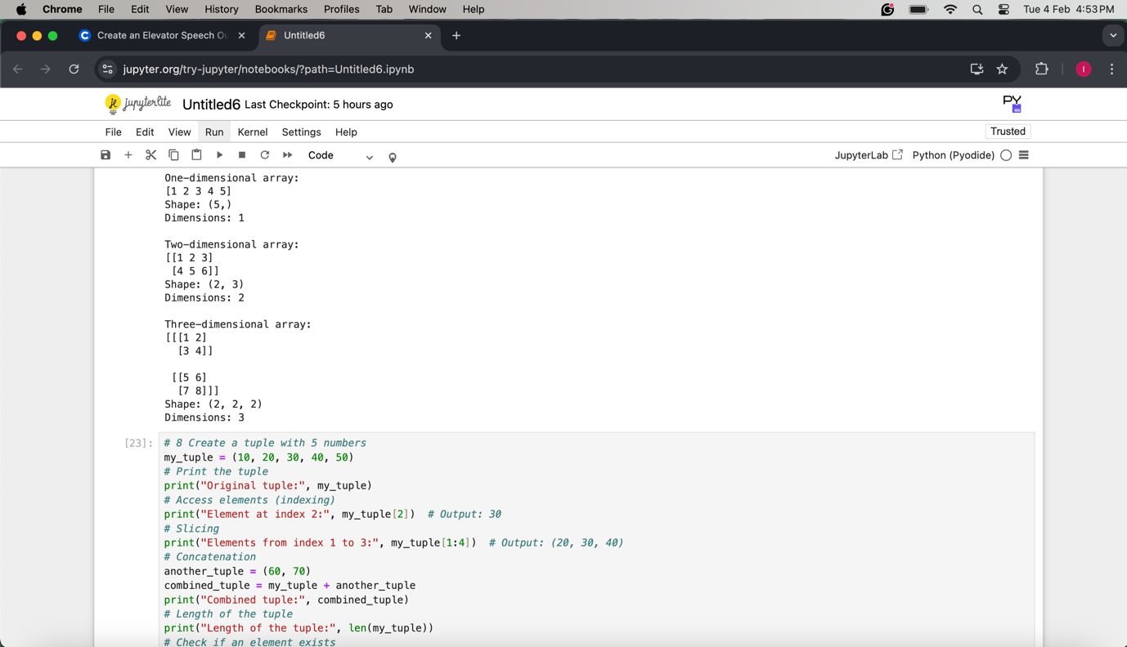



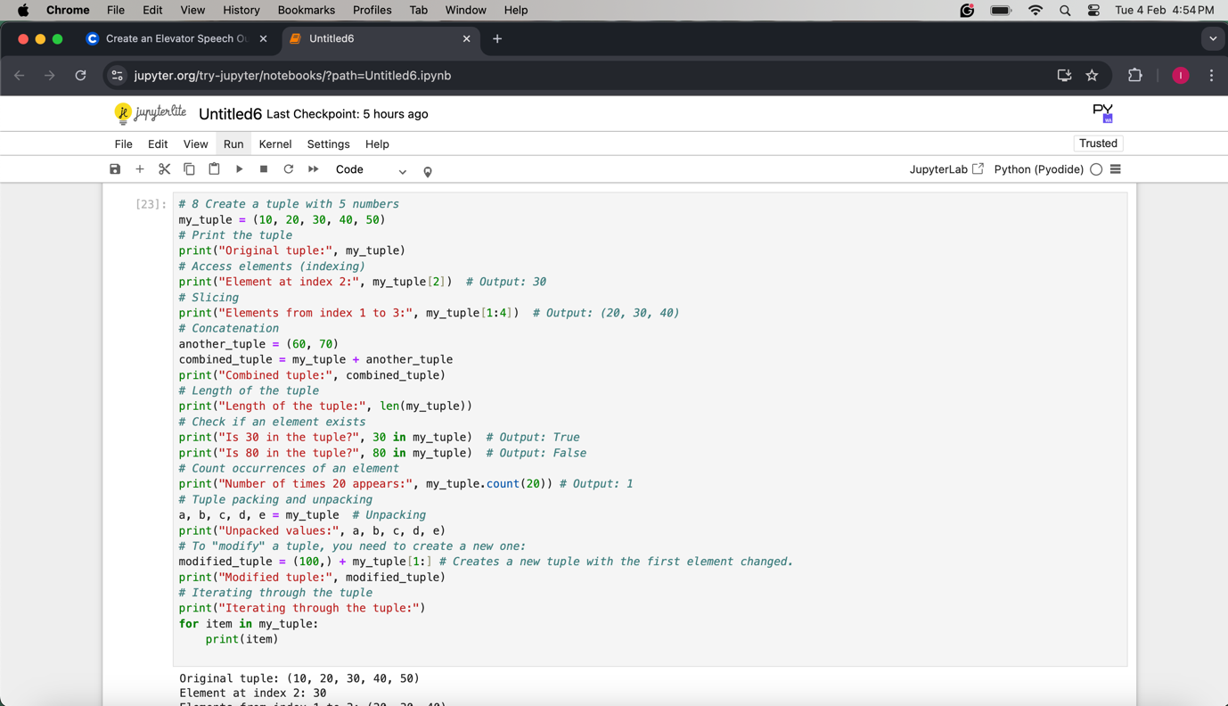

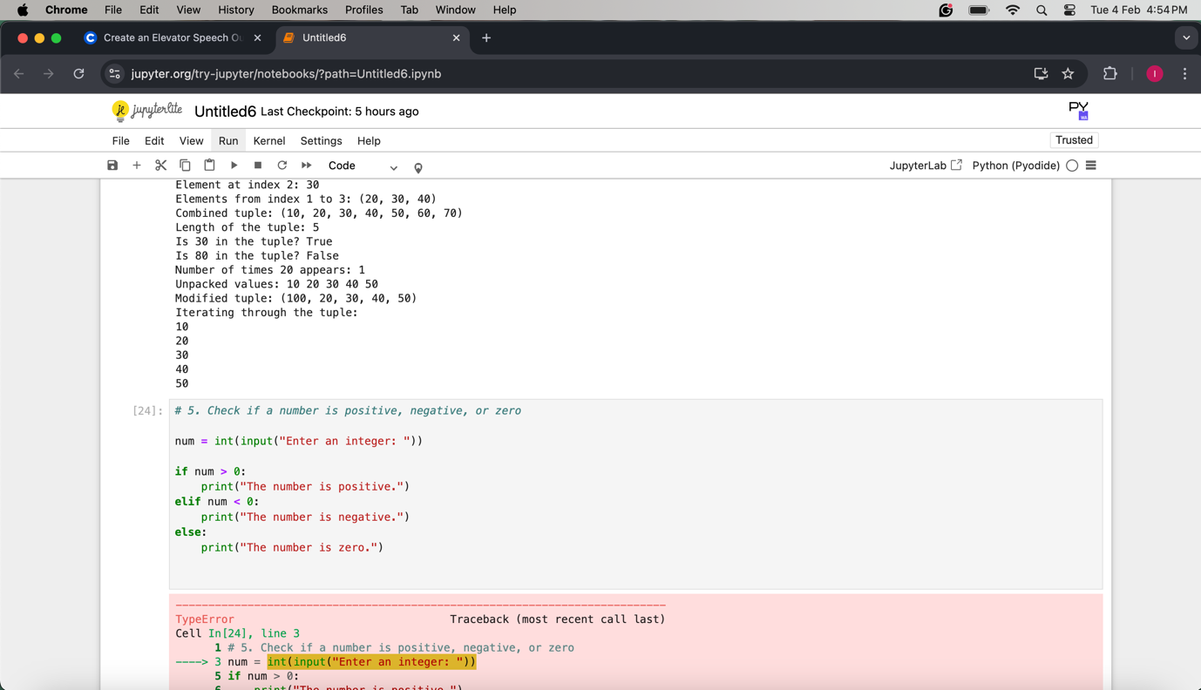

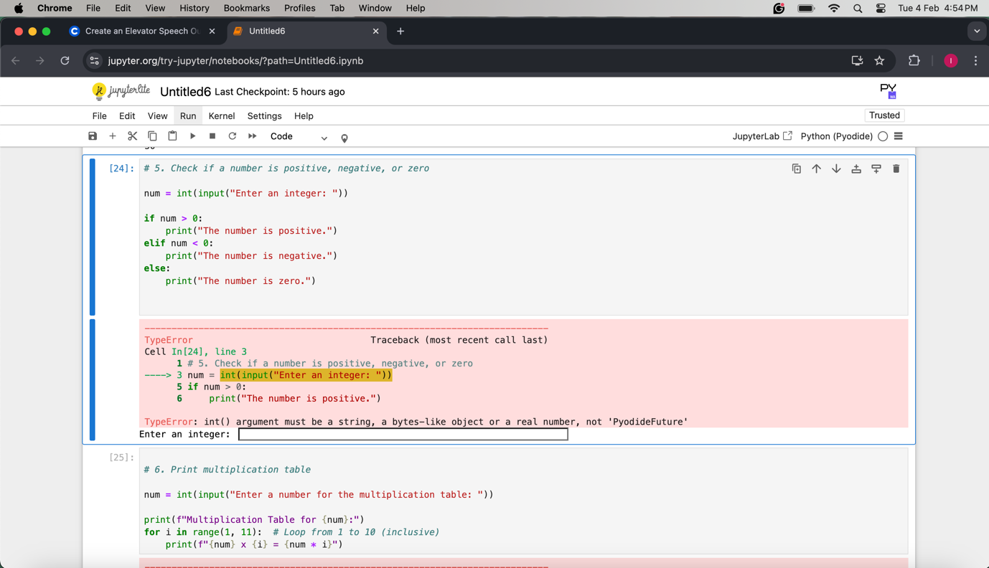

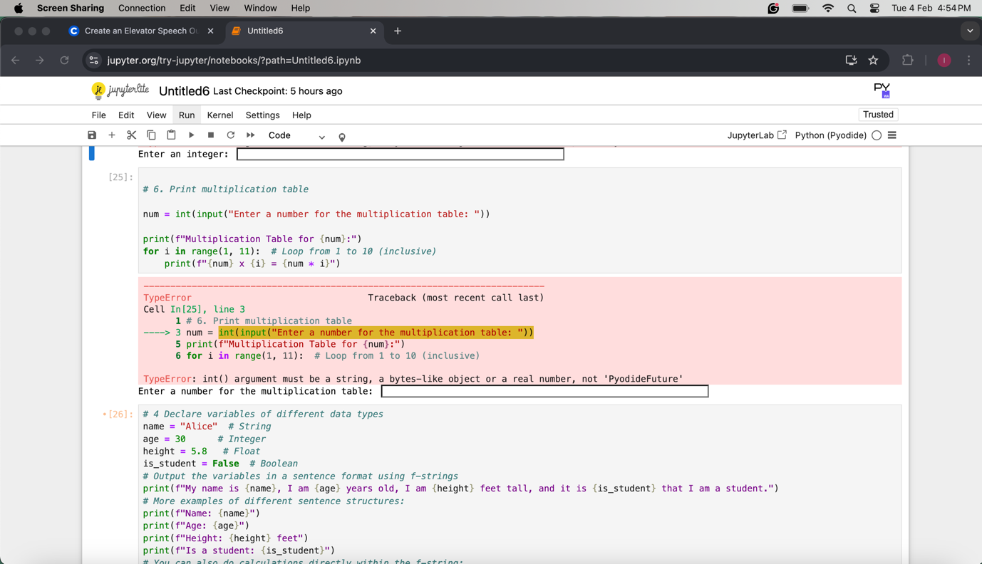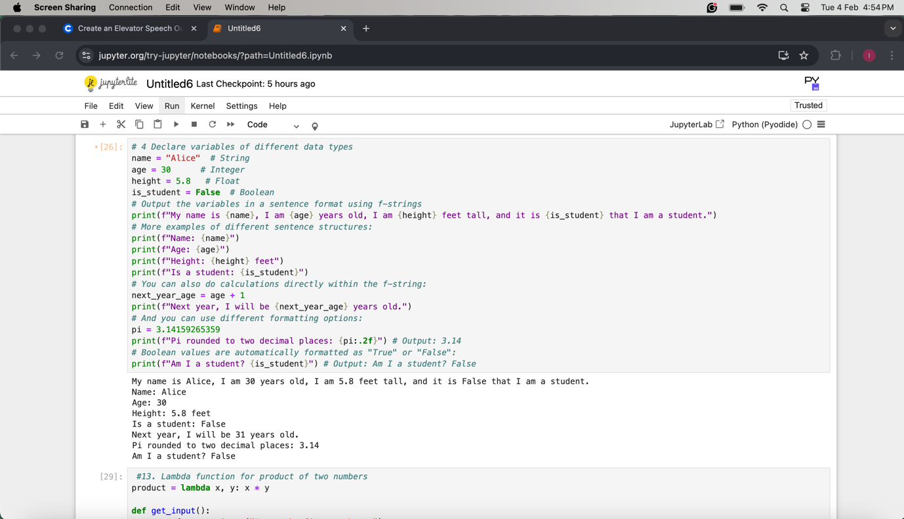

z